**BANK LOAN REPORT QUERY DOCUMENT**

**A.BANK LOAN REPORT SUMMARY**

**KPI’s:**

**Total Loan Applications**

SELECT COUNT('application_type') AS Total_Loan_Applications FROM financial_loan

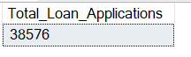

**MTD**

SELECT COUNT(application_type) AS MTD_Total_Loan_Applications

FROM financial_loan

WHERE MONTH(issue_date) = (SELECT MAX(MONTH(issue_date)) FROM financial_loan)

AND YEAR(issue_date) = (SELECT MAX(YEAR(issue_date)) FROM financial_loan)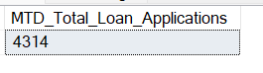

**MOM**

WITH CurrentMonth AS (

SELECT COUNT(application_type) AS MTD_Total_Loan_Applications

FROM financial_loan

WHERE MONTH(issue_date) = (SELECT MAX(MONTH(issue_date)) FROM financial_loan)

AND YEAR(issue_date) = (SELECT MAX(YEAR(issue_date)) FROM financial_loan)

),

-- Get the total number of loan applications for the previous month

PreviousMonth AS (

SELECT COUNT(application_type) AS Previous_Month_Total_Loan_Applications

FROM financial_loan

WHERE YEAR(issue_date) = YEAR(DATEADD(MONTH, -1, (SELECT MAX(issue_date) FROM financial_loan)))

AND MONTH(issue_date) = MONTH(DATEADD(MONTH, -1, (SELECT MAX(issue_date) FROM financial_loan)))

)

-- Calculate the MoM change percentage

SELECT

CM.MTD_Total_Loan_Applications,

PM.Previous_Month_Total_Loan_Applications,

CASE

WHEN PM.Previous_Month_Total_Loan_Applications = 0 THEN 0

ELSE ((CM.MTD_Total_Loan_Applications - PM.Previous_Month_Total_Loan_Applications) * 100.0

/ PM.Previous_Month_Total_Loan_Applications)

END AS MoM_Change_Percentage

FROM

CurrentMonth CM, PreviousMonth PM;T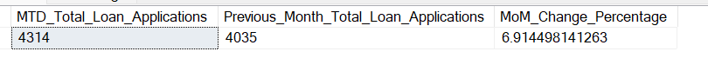

**Total Funded Amount**

SELECT SUM(loan_amount) as Total_funded_amount from financial_loan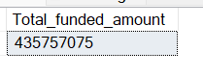

**MTD**

SELECT SUM(loan_amount) as Total_funded_amount

FROM financial_loan

WHERE MONTH(issue_date) = (SELECT MAX(MONTH(issue_date)) FROM financial_loan)

AND YEAR(issue_date) = (SELECT MAX(YEAR(issue_date)) FROM financial_loan)

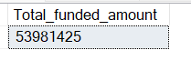

**MOM**

WITH CurrentMonth AS (

SELECT SUM(loan_amount) as Current_Total_funded_amount

FROM financial_loan

WHERE MONTH(issue_date) = (SELECT MAX(MONTH(issue_date)) FROM financial_loan)

AND YEAR(issue_date) = (SELECT MAX(YEAR(issue_date)) FROM financial_loan)

),

-- Get the total number of loan applications for the previous month

PreviousMonth AS (

SELECT SUM(loan_amount) as Previous_Total_funded_amount

FROM financial_loan

WHERE YEAR(issue_date) = YEAR(DATEADD(MONTH, -1, (SELECT MAX(issue_date) FROM financial_loan)))

AND MONTH(issue_date) = MONTH(DATEADD(MONTH, -1, (SELECT MAX(issue_date) FROM financial_loan)))

)

-- Calculate the MoM change percentage

SELECT

CM.Current_Total_funded_amount,

PM.Previous_Total_funded_amount ,

CASE

WHEN PM.Previous_Total_funded_amount = 0 THEN 0

ELSE ((CM.Current_Total_funded_amount - PM.Previous_Total_funded_amount ) * 100.0

/ PM.Previous_Total_funded_amount )

END AS MoM_Change_Percentage

FROM

CurrentMonth CM,

PreviousMonth PM;

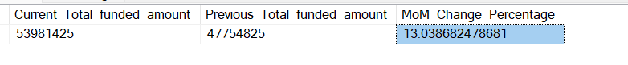

**Total Amount Received**

SELECT SUM(total_payment) as Total_Amount_Received FROM financial_loan

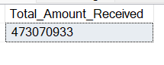

**MTD**

SELECT SUM(total_payment) as M_Total_Amount_Received

FROM financial_loan

WHERE MONTH(issue_date) = (SELECT MAX(MONTH(issue_date)) FROM financial_loan)

AND YEAR(issue_date) = (SELECT MAX(YEAR(issue_date)) FROM financial_loan)



**MOM**

WITH CurrentMonth AS (

SELECT SUM(total_payment) as M_Total_Amount_Received

FROM financial_loan

WHERE MONTH(issue_date) = (SELECT MAX(MONTH(issue_date)) FROM financial_loan)

AND YEAR(issue_date) = (SELECT MAX(YEAR(issue_date)) FROM financial_loan)

),

-- Get the total number of loan applications for the previous month

PreviousMonth AS (

SELECT SUM(total_payment) as P_Total_Amount_Received

FROM financial_loan

WHERE YEAR(issue_date) = YEAR(DATEADD(MONTH, -1, (SELECT MAX(issue_date) FROM financial_loan)))

AND MONTH(issue_date) = MONTH(DATEADD(MONTH, -1, (SELECT MAX(issue_date) FROM financial_loan)))

)

-- Calculate the MoM change percentage

SELECT

CM.M_Total_Amount_Received,

PM.P_Total_Amount_Received ,

CASE

WHEN PM.P_Total_Amount_Received = 0 THEN 0

ELSE ((CM.M_Total_Amount_Received - PM.P_Total_Amount_Received ) * 100.0

/ PM.P_Total_Amount_Received )

END AS MoM_Change_Percentage

FROM

CurrentMonth CM,

PreviousMonth PM;

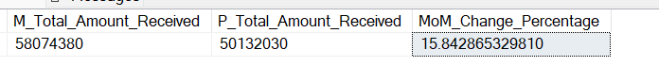

**Average_IR**

SELECT SUM(total_payment) as Total_Amount_Received FROM financial_loan



**MTD**

SELECT SUM(total_payment) as M_Total_Amount_Received

FROM financial_loan

WHERE MONTH(issue_date) = (SELECT MAX(MONTH(issue_date)) FROM financial_loan)

AND YEAR(issue_date) = (SELECT MAX(YEAR(issue_date)) FROM financial_loan)

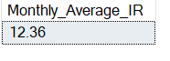

**MOM**

WITH CurrentMonth AS (

SELECT ROUND(AVG(int_rate),4)*100 as Monthly_Average_IR

FROM financial_loan

WHERE MONTH(issue_date) = (SELECT MAX(MONTH(issue_date)) FROM financial_loan)

AND YEAR(issue_date) = (SELECT MAX(YEAR(issue_date)) FROM financial_loan)

),

-- Get the total number of loan applications for the previous month

PreviousMonth AS (

SELECT ROUND(AVG(int_rate),4)*100 as Previous_month_Average_IR

FROM financial_loan

WHERE YEAR(issue_date) = YEAR(DATEADD(MONTH, -1, (SELECT MAX(issue_date) FROM financial_loan)))

AND MONTH(issue_date) = MONTH(DATEADD(MONTH, -1, (SELECT MAX(issue_date) FROM financial_loan)))

)

-- Calculate the MoM change percentage

SELECT

CM.Monthly_Average_IR,

PM.Previous_month_Average_IR ,

CASE

WHEN PM.Previous_month_Average_IR = 0 THEN 0

ELSE ROUND(((CM.Monthly_Average_IR - PM.Previous_month_Average_IR) * 100.0

/ PM.Previous_month_Average_IR ),4)

END AS MoM_Change_Percentage

FROM

CurrentMonth CM,

PreviousMonth PM;



**Average_DTI**

SELECT ROUND(AVG(dti),4)*100 as Average_Debt_to_Income_Ratio from financial_loan



**MTD Avg DTI**

SELECT ROUND(AVG(dti),4)*100 as M_Average_Debt_to_Income_Ratio

FROM financial_loan

WHERE MONTH(issue_date) = (SELECT MAX(MONTH(issue_date)) FROM financial_loan)

AND YEAR(issue_date) = (SELECT MAX(YEAR(issue_date)) FROM financial_loan)

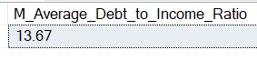

**MOM Avg DTI**

WITH CurrentMonth AS (

SELECT ROUND(AVG(dti),4)*100 as M_Average_Debt_to_Income_Ratio

FROM financial_loan

WHERE MONTH(issue_date) = (SELECT MAX(MONTH(issue_date)) FROM financial_loan)

AND YEAR(issue_date) = (SELECT MAX(YEAR(issue_date)) FROM financial_loan)

),

-- Get the total number of loan applications for the previous month

PreviousMonth AS (

SELECT ROUND(AVG(dti),4)*100 as Previous_Average_Debt_to_Income_Ratio

FROM financial_loan

WHERE YEAR(issue_date) = YEAR(DATEADD(MONTH, -1, (SELECT MAX(issue_date) FROM financial_loan)))

AND MONTH(issue_date) = MONTH(DATEADD(MONTH, -1, (SELECT MAX(issue_date) FROM financial_loan)))

)

-- Calculate the MoM change percentage

SELECT

CM.M_Average_Debt_to_Income_Ratio,

PM.Previous_Average_Debt_to_Income_Ratio ,

CASE

WHEN PM.Previous_Average_Debt_to_Income_Ratio = 0 THEN 0

ELSE ROUND(((CM.M_Average_Debt_to_Income_Ratio - PM.Previous_Average_Debt_to_Income_Ratio) * 100.0

/ PM.Previous_Average_Debt_to_Income_Ratio),4)

END AS MoM_Change_Percentage

FROM

CurrentMonth CM,

PreviousMonth PM;



Good_Loans_Application_Percentage

SELECT(

COUNT(CASE WHEN loan_status='Fully Paid' or loan_status='Current' THEN id END)*100)/

COUNT(id) AS Good_Loans_Application_Percentage from financial_loan

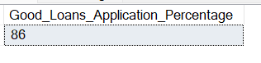

Good_Loans_Application

SELECT COUNT(id) as Good_Loans_Application from financial_loan where loan_status in ('Fully Paid','Current')



Good_loan_funded_amount

SELECT SUM(loan_amount) as Good_loan_funded_amount from financial_loan where loan_status in ('Fully Paid','Current')



Good_loan_amount

SELECT SUM(total_payment) as Good_loan_amount from financial_loan where loan_status in

('Fully Paid','Current')



Bad_Loans_Application_Percentage

SELECT(

COUNT(CASE WHEN loan_status='Charged Off' THEN id END)*100)/

COUNT(id) AS Bad_Loans_Application_Percentage from financial_loan



Bad_Loans_Application

SELECT COUNT(id) as Bad_Loans_Application from financial_loan where loan_status in ('Charged Off')

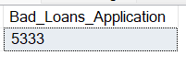

Bad_loan_funded_amount

SELECT SUM(loan_amount) as Bad_loan_funded_amount from financial_loan where loan_status in ('Charged Off')



Bad_loan_amount

SELECT SUM(total_payment) as Bad_loan_amount from financial_loan where loan_status in ('Charged Off')



Loan_Status

SELECT

loan_status,

COUNT(application_type) as Total_Application,

SUM(loan_amount) as Total_amount_funded,

SUM(total_payment) as Total_amount_received,

AVG(int_rate)*100 as Avg_IR,

AVG(dti)*100 as Avg_dti

FROM financial_loan group by loan_status

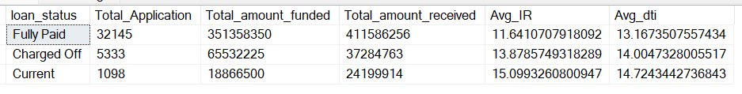

Loan_Status By MTD

SELECT

loan_status,

COUNT(application_type) as M_Total_Application,

SUM(loan_amount) as M_Total_amount_funded,

SUM(total_payment) as M_Total_amount_received,

AVG(int_rate)*100 as M_Avg_IR,

AVG(dti)*100 as M_Avg_dti

FROM financial_loan

WHERE MONTH(issue_date) = (SELECT MAX(MONTH(issue_date)) FROM financial_loan)

AND YEAR(issue_date) = (SELECT MAX(YEAR(issue_date)) FROM financial_loan)

group by loan_status

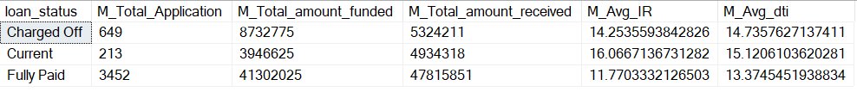

**----------------------FOR CHARTS--------------------------**

MONTHLY TREND BY ISSUE DATE

SELECT DATENAME(MONTH,issue_date) as Month_name,

MONTH(issue_date) as Month_no,

Count(id) as Total_Loan_Application,

SUM(loan_amount) as Total_amount_funded,

SUM(total_payment) as Total_amount_received

from financial_loan

group by MONTH(issue_date), DATENAME(MONTH,issue_date)

order by MONTH(issue_date)

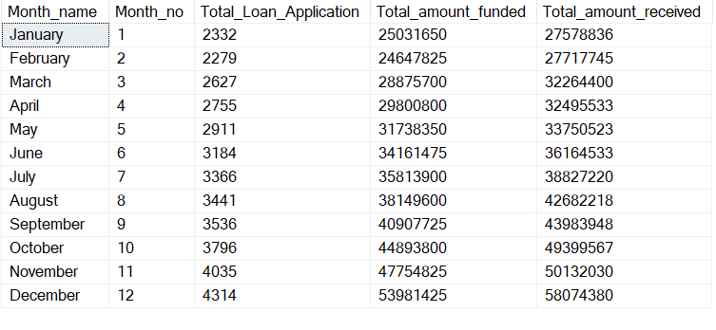

REGIONAL ANALYSIS BY STATE

SELECT address_state,

Count(id) as Total_Loan_Application,

SUM(loan_amount) as Total_amount_funded,

SUM(total_payment) as Total_amount_received

from financial_loan

group by address_state

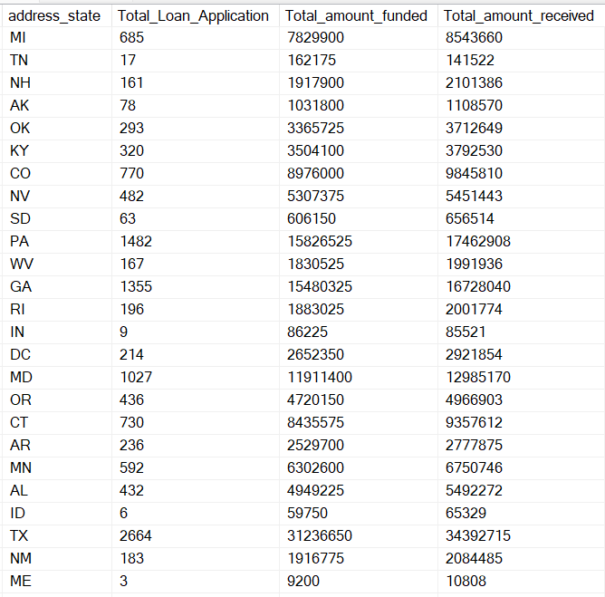

LOAN TERM ANALYSIS

SELECT term,

Count(id) as Total_Loan_Application,

SUM(loan_amount) as Total_amount_funded,

SUM(total_payment) as Total_amount_received

from financial_loan

group by term

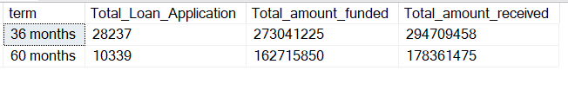

EMPLOYEE LENGTH ANALYSIS

SELECT emp_length,

Count(id) as Total_Loan_Application,

SUM(loan_amount) as Total_amount_funded,

SUM(total_payment) as Total_amount_received

from financial_loan

group by emp_length

order by emp_length

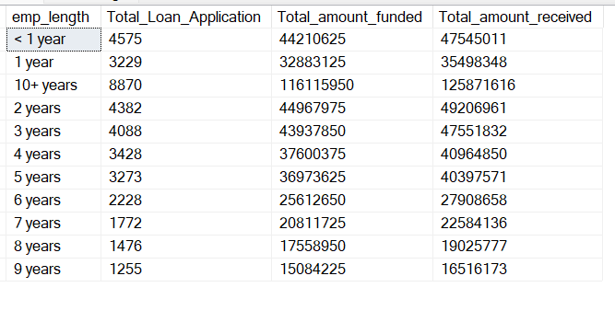

LOAN PURPOSE

SELECT purpose,

Count(id) as Total_Loan_Application,

SUM(loan_amount) as Total_amount_funded,

SUM(total_payment) as Total_amount_received

from financial_loan

group by purpose

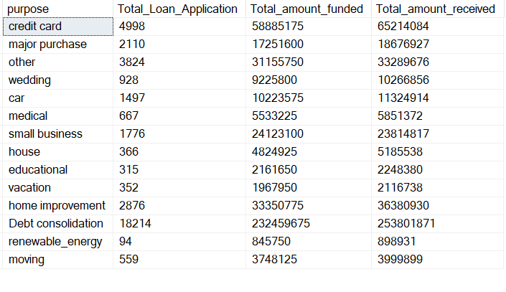

HOME OWNERSHIP

SELECT home_ownership,

Count(id) as Total_Loan_Application,

SUM(loan_amount) as Total_amount_funded,

SUM(total_payment) as Total_amount_received

from financial_loan

group by home_ownership

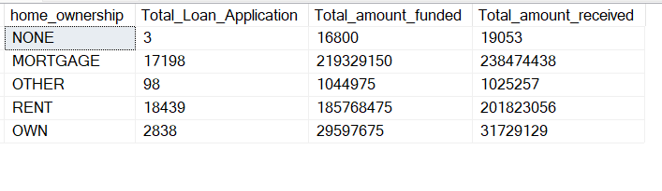

Verification_Status

SELECT verification_status,

Count(id) as Total_Loan_Application

from financial_loan

group by verification_status

